GNGB Annual General Meeting – Chief Executive Officer’s Report
October 2025
Michelle Bower, Chief Executive Officer

Dear Members,
Welcome to the 2025 Annual General Meeting. Thank you for taking the time to join us as we reflect on GNGB’s activities and progress over the 2024–2025 financial year.
It is my pleasure to present the Chief Executive Officer’s Report in support of the Chair’s Report and the GNGB Annual Financial Statements for 2025.
Delivering Value and Impact
The 2024–25 year has been one of change and growth, with GNGB focused on delivering value for money and measurable impact for our members, Gateway Operators, and the broader superannuation ecosystem.
Our activities this year were guided by the Board’s strategic priorities, which centre on ensuring the security and integrity of the Superannuation Transaction Network (STN). Through prudent management and focused investment, we have achieved strong outcomes that strengthen the network, improve resilience, and deliver long-term benefit to industry and government stakeholders.
Key Activities and Achievements
GNGB’s operational objectives continue to align with our strategic purpose — ensuring the stability and integrity of the STN while supporting Gateway Operators through change.
Building on the increased Commonwealth Grant funding from early 2024–25, GNGB has been able to expand its capability and deliver greater value through enhanced internal systems, deeper stakeholder engagement, and improved network coordination.
Highlights of the year include:
- Rebaselining the GNGB Operating Model to incorporate new capabilities aligned with the 2026 Strategic Plan.
- Enhancing risk management processes through implementation of new tools and automated reporting.
- Providing thought leadership on the payday super measure, promoting a collaborative and well-informed approach across the industry.
- Renewing and implementing our Stakeholder Engagement Strategy, including GNGB’s first stakeholder engagement survey in January 2024.
Together, these initiatives have positioned GNGB to deliver greater impact for the resources invested — ensuring that every dollar contributes to the resilience and security of the network.
Cyber Security
Cyber resilience remains a cornerstone of GNGB’s work, underpinning both our operational value and industry impact.
With the establishment of the Chief Information Security Manager (CISM) role, GNGB has been able to deepen engagement and coordination across the Gateway security community.
This year we have:
- Launched Gateway CISO Forums to promote collective learning and alignment across operators.
- Reviewed and streamlined the STN Information Security Requirements (ISR) to reduce duplication and deliver efficiency gains for Gateway Operators.
- Expanded the quarterly STN Cyber Forums, increasing participation and practical outcomes.
- Designed and delivered Operation Honey Bee II, the 2025 ecosystem-wide incident response exercise, strengthening collective preparedness and coordination.
GNGB will continue to identify opportunities to strengthen cyber resilience and support the already robust risk management practices of Gateway Operators.
Financial Management
Sound financial management remains at the heart of GNGB’s value proposition. The 2025 Financial Statements demonstrate our commitment to responsible stewardship and value for money, ensuring every investment aligns with strategic objectives and produces measurable outcomes.

Revenue Overview
The signing of the new Commonwealth Grant Agreement in late 2024 increased available funding, allowing GNGB to deliver an expanded work program without compromising efficiency. With CPI stabilising, Gateway Operator fees rose slightly in line with inflation.

Revenue Item | 2024 (‘000) | 2025 (‘000) | % change | Comments
Commonwealth Grant | 700 | 1,131 | 61% | Increased grant agreement
Membership Fees | 123 | 128 | 4% | Increased by CPI
Deferred Revenue (residual) | 80 | 298 | 275% | To be expected as capability is built and initiatives implemented
The benefits of the Government’s COVID-19 stimulus measures remain in retained earnings of approximately $100,000.
Unused grant revenue for 2024–25 is approximately $2.98 million, which is consistent with the time required to embed growth initiatives and implement new strategies.

A note on expenses
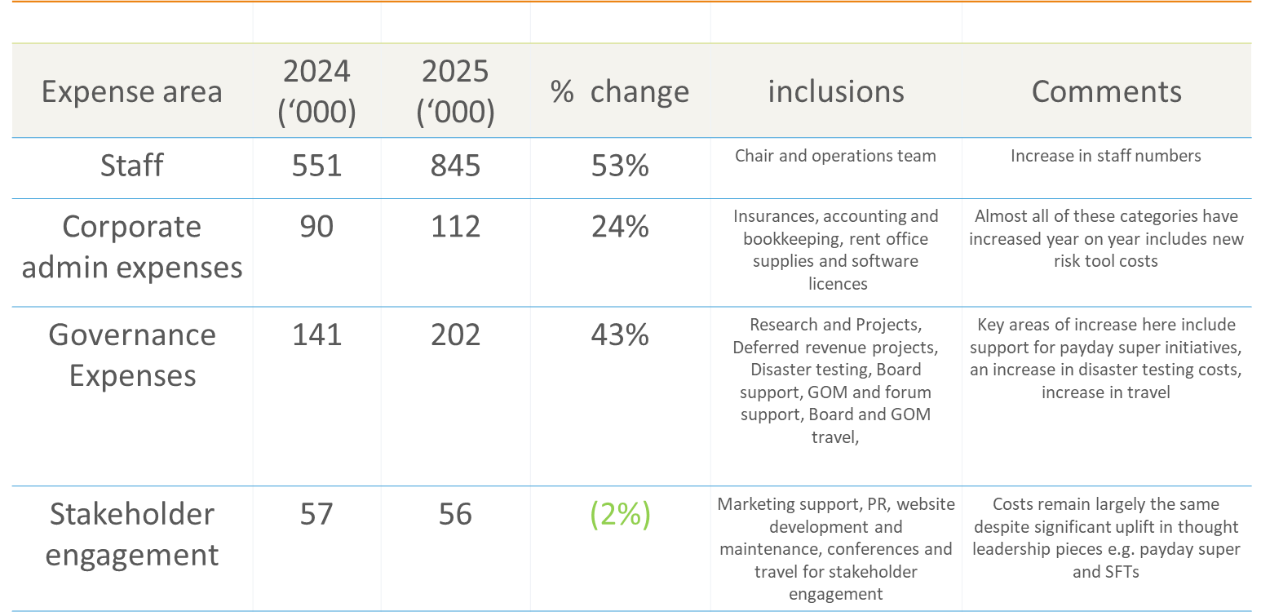
Auditor Reappointment
GNGB seeks member approval to reappoint HLB Mann Judd as auditor for the next period. HLB Mann Judd has conducted GNGB’s audits since inception, completing nine years to date.
Following a 2022 review of audit rotation best practices in the not-for-profit sector, the Board determined rotation was not yet required. However, consistent with good governance principles, the 10th audit year will be the last for this partner. A review process for appointing a new auditor will be undertaken ahead of the next member meeting.
2025–2026 Priorities: Turning Strategy into Action
Looking ahead, GNGB’s focus remains on translating strategy into tangible outcomes that strengthen the network and deliver value to all participants.
- Support for the implementation of the payday super measure, including:
  - Representing Gateway Operators to ensure practical, workable changes for the STN in relation to payday super.
  - Finalising the impact assessment of STN Governance Framework changes.
  - Developing an STN Availability Dashboard to improve transparency for industry.
  - Implementing STN Health Reporting to identify systemic risks and inefficiencies.
  - Facilitating interoperability testing and cooperation across standard changes.
- Embedding the new risk management tool into GNGB’s workflow and exploring broader applications.
- Expanding ecosystem resilience testing, building on the community established through Operation Honey Bee.
Acknowledgements
GNGB’s achievements are made possible through collaboration, expertise, and shared purpose.
- The GNGB team — Mary, Ross, and Sophie — for their professionalism, commitment, and passion for the STN.
- Jan, for her continued guidance, generosity, and dedication to GNGB’s mission.
- Our Directors for their advice, governance, and leadership.
- Co-sponsor members — FSC, ASFA, and DSPANZ — for their constructive partnership.
- Gateway Operators, whose innovation, adaptability, and commitment to excellence ensure the stability and integrity of the STN.
Together, we continue to strengthen the network, maximise the impact of every initiative, and ensure the best value for our members and the broader ecosystem.
Michelle Bower
Chief Executive Officer
GNGB

