Gateway Network Governance Body Ltd – Chair’s Report

20 October 2025
On behalf of the Board of Directors of the Gateway Network Governance Body Ltd (GNGB), I am pleased to present the 2024–2025 Annual Report. The GNGB has now completed its ninth year overseeing the security and integrity of the Superannuation Transaction Network (STN).
In an environment of constant geopolitical, economic, and social change, the GNGB remains focused on supporting superannuation stakeholders to ensure the STN remains secure, reliable, and available, enabling industry and employers to meet the requirements of the Data and Payments Standards.

Managing the Integrity of the Superannuation Transaction Network (STN)
Oversight of the security and integrity of the STN remains a central priority for the Board.
In 2024–2025, the GNGB oversaw the eighth annual audit of the STN’s security and the implementation of audit recommendations. The 2024 audit assessed Gateway Operators’ policies, systems, processes, and practices against the Information Security Requirements (ISR).
Results showed strong and improving compliance, with Gateway Operators demonstrating increased maturity in risk awareness and mitigation. This progress reflects a continuing commitment to maintaining and strengthening the integrity of the STN.

Strategy
A key role of the Board is to set and oversee the strategic direction of the GNGB, as outlined in its Constitution and the Memorandum of Understanding (MOU) with Gateway Operators.
Each year, the Board reviews the GNGB’s Strategic Plan to ensure priorities remain relevant and effective amid a rapidly evolving policy, regulatory, and technology landscape. It also closely monitors emerging risks to minimise potential impacts on the STN’s integrity and security.
In March 2025, the Board held a Strategy Planning Day to review progress and establish the platform for the 2025–2026 initiatives. The session revisited the GNGB’s design principles and examined its remit in the context of emerging changes such as the introduction of Payday Super. The Board reaffirmed the relevance of the current three-year strategic plan to 2026 and endorsed new initiatives across the five strategic pillars for 2025–2026.

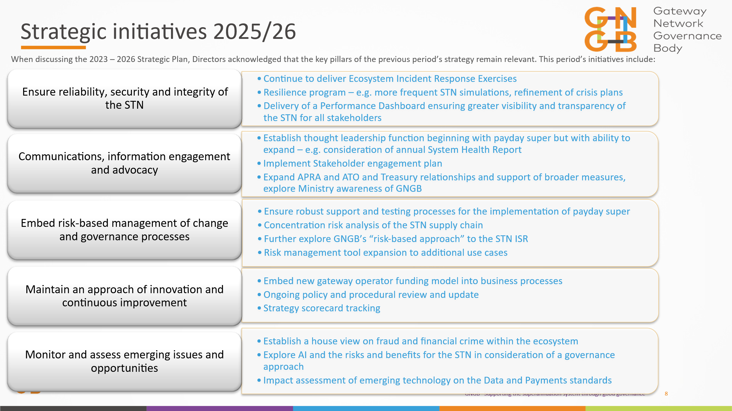

Cyber Security
In 2024, GNGB strengthened its internal capability by appointing a Chief Information Security Manager (CISM) — a role that has already proven invaluable to both the Board and Gateway Operators.
The Security Committee, established in 2018, continues to advise the Board on cyber and information security matters affecting the STN. Key initiatives approved by the Board include:
- Supporting Gateway Operators and the broader industry to stay informed on cyber-security issues
- Expanding participation in cyber incident simulations across the ecosystem
- Applying a risk-based approach to cyber governance
- Continuously testing and improving the information security framework
- Promoting open, collaborative discussions on cyber threats and solutions

Stakeholder Engagement
The GNGB continues to play an active role in engaging with industry and government on policy, legislative, and technological developments that may affect the STN.
Regular meetings are held with the ATO, and the GNGB participates in key consultations and conferences.
During 2024–2025, GNGB made significant contributions to government consultations, including:
- Payday Super – advocating to the ATO, Treasury, and Minister’s office to highlight both opportunities and challenges, and ensuring government understands how to leverage the STN’s data infrastructure.
- Digital ID reforms
- Modernising payments platforms and payments infrastructure changes.
- Successor Fund Transfers (SFTs) – promoting good practice and standardisation across the ATO, Treasury, and industry.

Board Renewal and Development
The GNGB Board brings together representatives from the Association of Superannuation Funds of Australia (ASFA), Digital Service Providers Australia New Zealand (DSPANZ), the Financial Services Council (FSC), employers, and Gateway Operators. This diversity of expertise supports robust discussion and informed decision-making.
Four committees support the Board:
- Remuneration Committee – oversees Chair and Executive remuneration
- Security Committee – provides leadership on STN protection strategies
- Governance Committee – monitors governance, risk, compliance, and financial management
- Thought Leadership Group – develops GNGB’s “house view” and supports advocacy and education.
The Board undertakes annual performance assessments to strengthen governance and identify development opportunities. In 2025, training was held on managing interests at the Board table, and an external evaluation confirmed a high standard of corporate governance. The Board Skills Matrix is regularly reviewed to ensure ongoing relevance and to inform succession planning.
I extend my gratitude to Hans van Daatselaar, who concluded six years of dedicated service as a Gateway Director, Chair of the Remuneration Committee, and member of the Security Committee.
We warmly welcome Mary Delahunty, appointed by ASFA, whose leadership and industry experience will further enrich the Board’s capability.

Financial Management
The Board received an unqualified audit of GNGB’s financial statements for 2024–2025, confirming sound financial management and transparent reporting. Funds from the APRA levy and Gateway Operator fees have been managed prudently, with strong oversight and accountability.
In 2025, an increase in Commonwealth Grant funding enhanced GNGB’s capacity to manage operational costs, modernise practices, and strengthen its sustainable operating model for the future.

Acknowledgements
I thank my fellow Directors for their commitment and professionalism in guiding the GNGB and upholding strong governance standards.
Special thanks go to Chief Executive Officer, Michelle Bower, and Operations Support Manager, Mary Costello, for their outstanding leadership in implementing GNGB’s strategic priorities, supporting the Board and Gateway Operators, and advancing continuous improvement. Thank you to Ross Daws, Chief Information Security Manager, for leading and supporting Gateway Operators in enhancing STN security and integrity.
I also welcome Sophie Weaver, who joined as Marketing and Communications Coordinator in April 2025 to cover for Erin Titus who is on parental leave and returns in January.
I would also like to extend thanks to Carmen Kearney who as a consultant has supported the team this year.
Finally, I express sincere appreciation to our stakeholders, Co-Sponsors, and Gateway Operators for their ongoing collaboration and dedication to improving the STN for the benefit of all superannuation members.

